|  |  |
| --- | --- |
| **Department** | **Engineering Mathematics and Physics** |
| **Division** | **-----------------** |
| **Academic Year** | **2019-2020 Preparatory** |
| **Course name** | **Computer** |
| **Course code** | **ECE001** |

**Title: -**

Operating Systems

By:

|  |  |  |  |
| --- | --- | --- | --- |
|  | Name | Edu mail | B.N |
| 1 | Mohamed Nasser Mohamed Fares | muhammed195901@feng.bu.edu.eg | 809 |

**Examiners committee**

|  |  |
| --- | --- |
| **1** | **Dr. Ahmed Bayoumi** |
| **2** | **Dr. Shady Elmashad** |
| **3** | **Dr. Abdelhamid Attaby** |

GitHub link:

<https://mohamednasserfares.github.io/html-project-repository/>

page link:

<https://mohamednasserfares.github.io/html-project-repository/>

Topic

I talked about operating systems, so I first defined them: they are software systems that run programs and programs such as Internet browsers, media programs, text editing programs, and other famous programs; It is not possible to browse the Internet or work on a computer without the presence of this system. All applications used on a computer require a specific operating system to function fully. As it is possible to define the operating system as a program of a special nature, it acts as a graphic interface between the user and the computer components. And secondly, I wrote about (systems departments): where operating systems are divided into two main parts according to allowing more than one operation to be executed at one time, or only one operation at a given time, and operating system sections are: (multi-tasking and multi-user systems): are the systems that It allows more than one operation to be performed at the same time, and allows more than one user to use the software and applications on the computer. (Single-task and single-user systems): are systems that do not allow more than one operation to be performed at one time, and do not allow more than one user to use different applications on a computer. And third (operating system functions): The operating system performs many functions that make computer use possible for humans; Given that the computer language does not resemble the human language, and dealing with it needs a programming language that acts as a mediator between the user and the computer with its various components, the operating system implements different programs and applications, and it performs input and output operations such as dealing with the keyboard, screen, and sound, and corrects the programming errors that occur during Executing various processes and software, processes special system files, and organizes the use of computer components.

Then I finally talked about the types of operating systems, including: (Windows, Disk Operating System, LINUX, Mac OS X, Haiku, MENUET, eComStation AND TAILS). And I mentioned the ratios of the most used operating systems, and of course, the Windows system is the most used system in its various versions.

Screen shot from the web page:

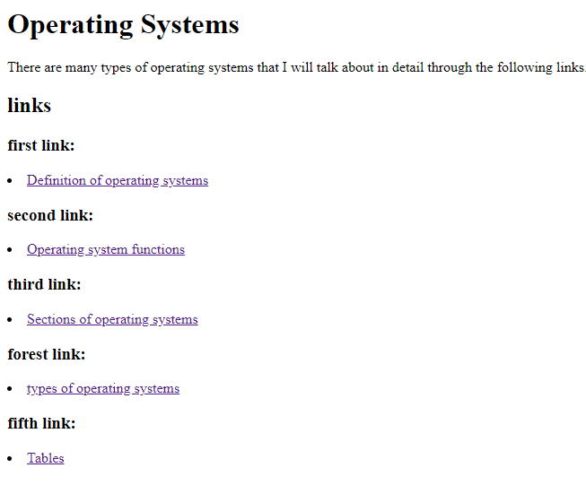

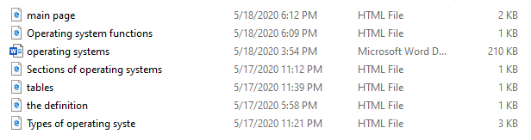

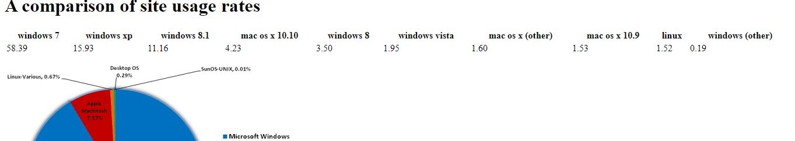

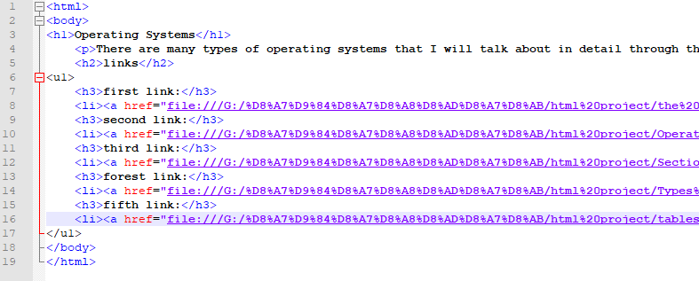Screen shot of codes:

